Practical 3: Overloading, Code Coverage and Number Formatting
- Create the following Box class in a project called PBox
Box
private double height
private double width
private double length

public Box(double height, double width, double length)
public Box(double squareBase, double height)
public Box(double size)

public double getHeight()
public double getWidth()
public double getLength()

public void setHeight(double height)
public void setWidth(double width)
public void setLength(double height)

public double calcVolume()
public double calcSurfaceArea()

public String toString()

Code the toString method to return the height, width and length of your box as well as the volume and surface area.

In your BoxApp class create 3 objects, a perfect cube –all sides the same length, a box with a square base –length and width the same, a box with length, height and width all different. For each call their toString methods.

Now create your unit tests to formally test each method that you have written. Test them on the above “normal” boxes and test for “unusual” cases.

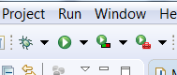
Running Coverage
Open Box.java
Write and run your JUnit tests.
Click on the coverage icon.
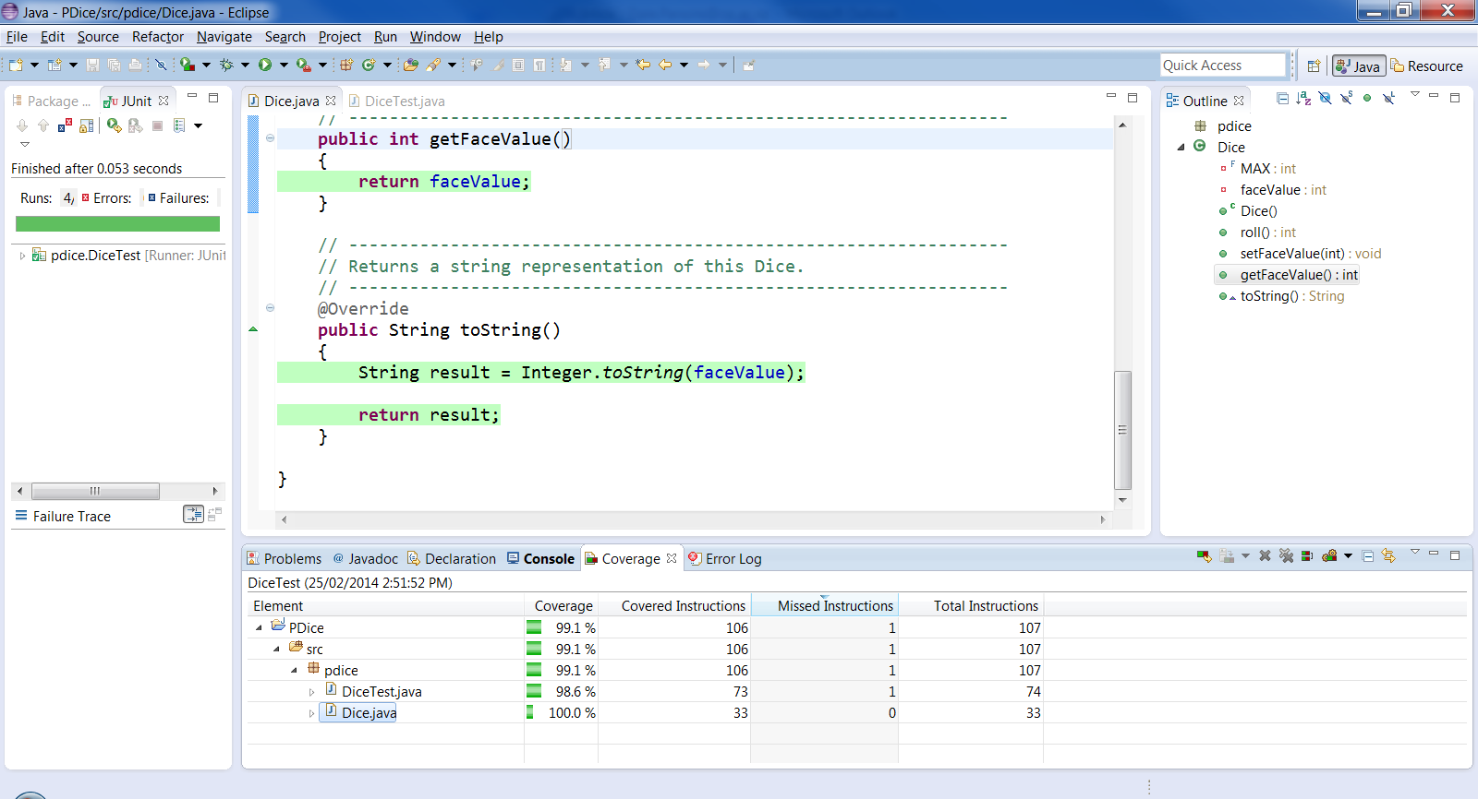
Remove highlighting
Only interested in the class under test

Observe green highlighting in the source code window of the java class. Any lines of code inside a method that are not green have not been tested. Ignore any highlighting in the test class or the app class. The only coverage percentage of interest is the java class not the app or test class.
- Check the code coverage on your Salary and Box class. Add in extra assertEquals statements if you do not have full coverage.

- Create a class that accepts a temperature in Celsius and converts that temperature to Fahrenheit and Kelvin.
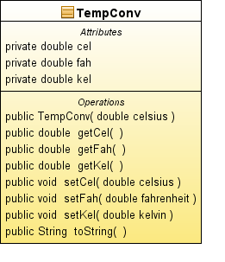

From | To Fahrenheit | To Celsius | To Kelvin
Fahrenheit (F) | F | (F - 32) * 5/9 | (F - 32) * 5/9 + 273.15
Celsius (C or º) | (C * 9/5) + 32 | C | C + 273.15
Kelvin (K) | (K - 273.15) * 9/5 + 32 | K - 273.15 | K

I know that setFah(67) will convert to 19.44444444444443C and 292.44444444444446K use the DecimalFormat class in your app class to show these temperatures to only 2 decimal places.

In your Test class test on a range of numbers, 20C, 17 C, 0 F, 0K, 456K…. use
https://www.metric-conversions.org/temperature/fahrenheit-to-celsius.htm. To achieve the checkpoint mark, your code coverage of the Temp class must show 100%.

